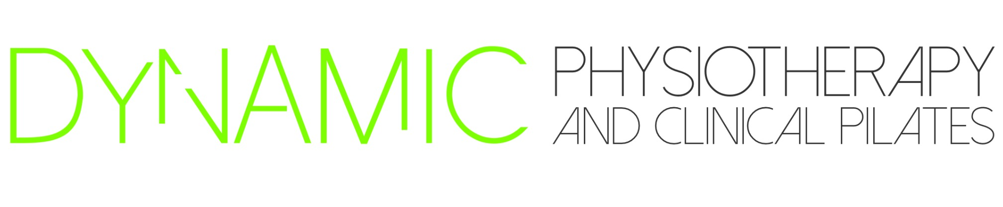
Is seeking……
Accredited Exercise Physiologist for 2023

Part-time Accredited Exercise Physiologist 30 hours per week with the option of increasing hours up to full time if preferred by the successful applicant.

Must have current ESSA registration, Victorian Police Check, Working with Children check, First Aid/CPR Certifcate, COVID vaccinations.

Dynamic Physiotherapy and Clinical Pilates is a vibrant Allied Health Clinic combining Physiotherapy and Clinical Pilates. We are located on the Great Ocean Road, 3 hours from Melbourne. Warrnambool is a beautiful place to live so why not come and explore what it has to offer.

Our focus at Dynamic Physiotherapy and Clinical Pilates is to offer a caring approach to our clients therapy needs. We have a modern approach to health care, based around professional development and the latest evidence based practice. We build on team empowerment by entrusting team members with a high level of allocated responsibility throughout the daily operations.

Our team currently consists of 1 Principle Physiotherapist and 1 Administration member, but we are looking to grow. We have been in business since 2015 and have a strong referral base.

Dynamic Physiotherapy and Clinical Pilates offers a flexible working environment and strongly encourages Work/life balance. We are seeking part time, negotiable employment of up to 30hours with the option of increasing those hours as we grow.

Our new AEP would need to be a team player, enthusiastic, interested in our community involvement and passionate about furthering their career. New graduates are welcome to apply, however we also value previous experience. The successful applicant must also be personally and professionally aligned with the values that represent Dynamic Physiotherapy and Clinical Pilates.

We work together professionally as a team and our culture is something unique. If this sounds like a team you would like to be a part of, please apply via cover letter and curriculum vitae. If you would like to know more about the position please get in touch. Please email your application to jess@dynamicpilates.biz. We will respond to your application within 2 days of receiving them and let you know more about our recruitment process from there.
Join a healthcare team focused on delivering quality patient services.

